# DRAFT NHS Oversight and Assessment Framework (accessible version)



Contents

1. Introduction 3

2. Purpose and principles 4

2.1 Oversight and Assessment 5

3. Roles and Responsibilities 7

3.1 Oversight of Providers 7

4. Oversight cycle 11

4.1 Monitoring 14

4.2 Identifying the scale and nature of support or intervention needs 16

4.3 Implementing support or intervention activity 20

4.4 High-performing organisations 21

5. Assessment 21

5.1 ICB Annual Performance Assessment 21

5.2 ICB Capability Assessment 23

5.3 Evaluating Provider Capability 25

Annex A: ICB functional areas and supporting activities 27

Annex B: Proposed annual self-certifications for providers 34

Annex C: Recovery Support Programme 35

Annex D: 2024/25 Oversight Framework delivery metrics 39

1. Introduction
2. The NHS England [operating framework](https://www.england.nhs.uk/wp-content/uploads/2022/10/B2068-NHS-England-Operating-Framework.pdf) published in October 2022 sets out how our ways of working have evolved to reflect the development of integrated care systems (ICSs). It describes how NHS England works with integrated care boards (ICBs), providers, and wider system partners to improve local health and care outcomes and maximise value for taxpayer money.
3. Detailing our approach to NHS oversight and assessment is critical to the implementation of our operating framework building on our commitment to support ICBs to achieve full maturity. Following the coming-together of NHS England and NHS Improvement we published our first System Oversight Framework in September 2021. This was replaced by an updated NHS Oversight Framework published in July 2022 to coincide with the establishment of ICBs.
4. We committed to work with ICBs to update the NHS Oversight Framework to ensure that oversight and performance arrangements are streamlined. This NHS Oversight and Assessment Framework is the result of that work. It builds on our previous NHS Oversight Framework and the foundations set out in our operating framework reinforcing our ambition for a system-led approach to integrated care established in the [NHS Long Term Plan](https://www.longtermplan.nhs.uk/) and put on a statutory footing in the Health and Care Act 2022. The framework highlights the importance of all partners playing their part in mutually successful systems as well as balancing the need to deliver against immediate priorities and longer-term sustainable improvement. Our approach ensures that we:
   * + - 1. have a robust process of oversight and accountability that rewards improvement and brings all parts of the NHS system together around common goals
         2. have a clear approach to developing leadership capability in line with the findings of the Messenger Review, giving leaders the tools they need and the competency to drive change
         3. can explain how improvement will be delivered through the principles established as part of NHS IMPACT and NHS England’s support offer.
5. The framework applies to ICBs and providers[1] and it supports NHS system[2] partners to develop approaches to oversight that reflect:
6. a shared understanding of the accountabilities and roles between each member of the NHS system, how performance is monitored, and how support or intervention needs are identified and addressed;
7. the importance of delivery against both individual and shared system priorities
8. Purpose and principles
9. This framework is designed to enable local system partners to lead effectively and transform care within their locality. It sets out the processes by which positive changes are supported to thrive and challenges to driving improvement are quickly identified, diagnosed and responded to together. It serves four core purposes:
   * + - 1. to align priorities across the NHS and with wider system partners to drive shared ownership of improvement
         2. to enable good practice to flourish and be shared to support mutual improvement
         3. to identify where ICBs and/or providers may benefit from or require support or intervention
         4. to provide an objective basis for decisions about when and how we may intervene using our regulatory powers should this be necessary
10. The approach to oversight is characterised by the following key principles:
    * + - 1. compassionate leadership behaviours that underpin all interactions, informed by the leadership behaviours set out in our operating framework (see Figure 1)
          2. balancing the contributions of individual organisations with shared system performance and outcomes
          3. working in partnership with ICBs to discharge our respective responsibilities
          4. promoting system-led improvement and mutual accountability between system partners

By consistently living these behaviours we aim in the new NHS England to:

* **Work as ‘one team’ across the NHS (ICBs, providers and NHS England) with our partners, being collaborative and empowering each other** – but also being clear about who is accountable for what.
* **Seek co-creation and ownership** of our strategy, priorities and support offers – both within the NHS team and with partners – and demonstrate collaborative leadership.
* **Be inclusive and value diversity** – make sure that no one feels excluded and listen to all perspectives.
* **Work at pace when appropriate and be agile** – streamlining how we make decisions, avoiding duplication and multiple layers where we can.
* **Learn by doing** – acting, evaluating and continuously improving.
* **Be transparent and honest** – in all our interactions and activities.

Figure 1: Leadership behaviours, NHS England Operating Framework, Pg. 13

* 1. Oversight and Assessment

1. Figure 2 sets out an overview of NHS England’s oversight and assessment approach. For this document, oversight and assessment are defined as:
   1. Oversight is the ongoing monitoring of performance and quality of services being delivered by the NHS, to manage the delivery of the priorities set out in [NHS planning guidance](https://www.england.nhs.uk/operational-planning-and-contracting/), the NHS Long Term Plan, and the [NHS Long Term Workforce Plan.](https://www.england.nhs.uk/publication/nhs-long-term-workforce-plan/) Its purpose is to provide assurance of performance and delivery as well as identify areas of challenge and those requiring support or intervention. The oversight framework specifically sets out how ICBs and NHS Trusts and Foundation Trusts are overseen, it does not cover the oversight of primary care providers who are overseen by ICBs in line with their delegated commissioning responsibilities.
   2. Assessment is the process by which we judge an organisation’s capability and governance. For ICBs, NHS England has a statutory responsibility to conduct a performance assessment for each financial year. We have no similar statutory duty as respects providers, but we work alongside the Care Quality Commission to ensure that these organisations are providing safe and effective care and delivering services in line with the conditions of their provider license.
2. We have built our approach around oversight of delivery against relevant NHS priorities via the oversight cycle and an assessment of organisational capability.

|  |  |  |
| --- | --- | --- |
| **Oversight Cycle**  **(Section 4)** | **Integrated Care Boards** | * Annual and quarterly **delivery segmentation** – a single number (1-4), derived from:   + ongoing review of performance and annualised performance against ICB’s oversight metrics   + consideration of wider system delivery across specific areas (e.g. finance, access)   + incorporating the ICB capability assessment (see below)     - * + All ICB segmentations to be reviewed and published by NHSE following discussions with the ICB. |
| **Providers** | * Quarterly **delivery segmentation** – a single number (1-4), based on: * ongoing review of performance and annualised performance against provider oversight metrics * a consideration of wider system delivery across specific areas (e.g. finance, access) * incorporating our views of the provider’s capability * All provider segmentations to be reviewed and published by NHSE following discussions with the ICB. |

|  |  |  |
| --- | --- | --- |
| **Assessment**  **Cycle**  **(Section 5)** | **Integrated Care Boards** | * Based on assessment of the ICB’s ability across 6 functional areas * Incorporating ICB self-assessment, CQC and stakeholders’ views * Resulting in **an overall capability rating** – ‘insufficient progress’ / ‘progressing’ / ‘achieving’ / ‘excelling’ * We will use the capability assessment to moderate the ICB’s delivery segment. |
| **Providers** | * Assessing **provider management and organisational health**, based on   + CQC well-led rating   + a provider self-certification and track record   + third party information   + We will use the capability assessment to moderate the provider's delivery segment. |
| * Delivery segments and capability assessments determine **how we work with ICBs to oversee providers** (section 3) * The delivery segmentation **will drive NHS England's response**, e.g. provision of support, increased scrutiny, and/or direct intervention (section 4) * The ICB **capability rating** and an annual **delivery segmentation** will be published as part of the **ICB annual assessment** (section 5) | | |

Figure 2: An overview of NHS England’s oversight and assessment approach

1. A critical element of the oversight cycle (see figure 3) is the early identification of emerging issues and concerns so that they can be addressed before they have a material impact or performance deteriorates further. ICBs and providers are expected to escalate issues where there are significant actual or prospective changes in performance or quality risks in line with our operating framework.

Figure 3: the oversight cycle

1. Roles and Responsibilities
2. The NHS England Operating Framework defines each organisation’s roles and responsibilities in oversight. We are responsible for overseeing the performance of ICBs and providers but may choose to ask ICBs to carry out the oversight of providers in their NHS systems in the first instance.
3. ICBs are responsible for arranging for the provision of healthcare services to meet the health needs of its local population, alongside other statutory duties. The ICB is the leaders of the NHS system within its ICS and oversees the delivery of joint system plans and strategies requiring mutual accountability. A key element of discharging its responsibilities is to ensure that the service-delivery models in its NHS system are working effectively via place-based partnerships, provider collaboratives, the primary-secondary care interface and integrated neighbourhood teams. It should lead the oversight of individual providers in line with the principles outlined in this document, and co-ordinate support or interventions within its NHS system, where appropriate, working in partnership with us. We also expect all ICBs to have a robust commissioning approach that works with local communities, providers of health care services and their local authorities in a partnership manner.
4. Providers are responsible for providing safe, effective, efficient, and high-quality services. The provider must work effectively with its NHS system partners to deliver its contributions to shared objectives, plans and priorities, including financial and operational performance. It must comply with the NHS provider licence and standards set by regulators.
   1. Oversight of Providers
5. ICBs and NHS England both have responsibilities to oversee providers under the NHS Act 2006. ICBs, using their contractual powers, ensure the services they commission from the provider are high quality, value for money and sustainable. NHS England ensures the timely and proportionate use of its statutory powers to intervene and if necessary, require action from providers that are at risk of underperformance. In particular, this involves the use of our statutory powers to take enforcement action against a provider if there is a suspected or actual breach of its licence.
6. In line with our Operating Framework, we aim to discharge our responsibility for overseeing providers through[3] the relevant ICB, asking the ICB to oversee the providers in the first instance. In some circumstances, however, we may need to take a more direct role and oversee providers with the ICB as partners, such as when a provider requires intensive support or intervention or when an ICB has a capability rating of ‘Progressing’ or ‘Insufficient Progress’. (See section 5.2 for ICB capability).
7. Wherever there are areas of challenge or improvement opportunities or services not being delivered to standards we all aspire to, we will work with the ICB and other areas of the system as needed to provide support and otherwise intervene as needed to ensure systems able to deliver high quality care to the desired standard. This will build on our successful approach to elective, cancer and urgent care recovery to ensure intervention is targeted and proportionate and drives rapid improvement.
8. The oversight responsibilities of ICBs include, but are not limited to:
   * + - 1. Overseeing the commissioning and management of contracts, delegation and partnership agreements with providers;
         2. Leading the day-to-day oversight of providers across their NHS system, including but not limited to provider collaboratives, providers that function across multiple ICSs, independent providers, and primary care providers to ensure effective arrangements are in place to deliver on plans, performance, outcomes, and transformation;
         3. Advising us on the support or intervention needs of their providers within their NHS system by the principles of oversight detailed in this framework, and supporting the resolution of these issues per agreed recovery plans;
         4. Managing NHS system-wide risks and delivery against performance, quality, and financial plans, and acting as liaisons with us for matters relating to providers in their NHS system (except for those services directly commissioned by us), including timely and transparent escalation of issues;
         5. Working in partnership with providers, alongside other partners, to find local resolutions to risks, concerns and challenges, and co-ordinate and tailor necessary support or intervention; and
         6. Providing assurance and input into regulator assessments of providers and NHS systems, including those led by CQC.
9. We determine our level of confidence in an ICB’s capability through a review process with an aspiration that all ICBs will reach a rating of “Excelling” or “Achieving”. For those ICBs rated ‘Excelling’ or ‘Achieving’ they will generally lead the oversight of providers that have a segment of 1 or 2 (see section 4.2 for segmentation) in their NHS systems, and work in partnership with us for the oversight of providers that have a segment of 3 or 4. Capability will be assessed on an annual basis as well as on an ad hoc basis by exception where we become aware of any issues.
10. ICBs are at different stages of maturity and for those not yet at the “Achieving” or “Excelling” capability level we recognise the need to work together more closely. For ICBs that have a capability rating of ‘Progressing’ or ‘Insufficient Progress’, we will work with them in partnership to jointly oversee providers in that NHS system.
11. The common principles for both scenarios include:
    1. Provider oversight arrangements for each NHS system are set out in the annual assessment letter from the Regional Director to each ICB’s Chair and CEO;
    2. ICBs recommend support or intervention for a provider to us where required but we will make the final decision on any support or intervention required; and
    3. ICBs play an active role in:
       1. proposing the improvement criteria providers in receipt of formal support or intervention have to meet to exit intervention; and
       2. support the provider in meeting those criteria.
12. The key features of our oversight of providers with or through an ICB are detailed in Table 1.

|  |  |
| --- | --- |
| **Provider oversight led though an ICB rated as excelling or achieving** | **Provider oversight led with an ICB rated as progressing or insufficient progress** |
| * In terms of oversight, we typically do not have contact with the provider without the ICB except for agreed circumstances e.g. direct commissioning relationships, exceptional challenges including significant underperformance in key national priority areas. * The ICB oversees performance, quality, finance, and delivery against system plans through robust governance arrangements and review meetings with providers; * ICB and provider have open and mature discussions on issues and challenges, including any early warning signs, and agree way forward; * ICB acts as a liaison for the provider with NHS England and escalates issues timely and transparently; * ICB proactively manages system and provider risks, seeking support as and when required; * ICB finds local resolutions to issues and challenges in a provider through leadership, peer support, facilitating mutual aid, etc.; * ICB reports to NHS England as necessary on provider-level performance, quality, finance, and progress towards agreed targets. * NHS England makes final decisions on segmentation and enforcement action, where necessary. * NHS England may work directly with some providers to understand best practices and improvement opportunities. | * NHS England oversees the provider with the ICB (potentially through a jointly-chaired forum) with shared regular review meetings to discuss quality, performance, finance, and progress against improvement plans; * NHS England provides direct oversight and support to providers with the awareness of the ICB; * NHS England actively supports the ICB in managing risks related to the provider’s issues, and finding resolutions to issues and challenges; * NHS England makes the decision on the structure of support or intervention for the provider (having regard for the ICB’s advice) including whether to seek entry into the Recovery Support Programme and/or to take enforcement action; * NHS England works with the ICB to agree on an improvement plan for challenged providers, sets the ‘improvement criteria’ and planned timelines for any support or interventions, and takes an active role alongside the ICB to monitor progress and support providers in meeting those criteria. |

Table 1: Oversight of providers with and through ICBs

1. For providers working across multiple ICBs, the lead commissioner (i.e. the ICB to which the provider is apportioned for financial control purposes per the [NHS Data Service Directory](https://digital.nhs.uk/services/organisation-data-service/export-data-files/csv-downloads/other-nhs-organisations)[4]) is responsible for the provider’s oversight relationship with NHS England. They will, however, work with other commissioners to avoid duplication or to address specific issues e.g. ambulance service delivery where the provider works across a wide geography.
2. For independent providers, ICBs are expected to oversee quality and performance through contractual levers and escalate quality concerns using appropriate regional forums. We continue to oversee certain independent providers and NHS-controlled providers under [the Independent Provider Risk Assessment Framework (IPRAF)](https://www.england.nhs.uk/long-read/risk-assessment-framework-and-reporting-manual-for-independent-sector-providers-of-nhs-services/) and NHS Oversight and Assessment Framework respectively, working with relevant ICBs as appropriate.
3. Regardless of whether oversight of providers is being carried out with or through the relevant ICB, providers continue to remain accountable to NHS England under the terms of the Act. We may work directly with providers regardless of their segment in certain situations including:
   1. Where we directly commission services of the provider such as health and justice, armed forces, and highly specialised healthcare services. The standard oversight arrangements apply for services whose commissioning has been delegated from NHS England to ICBs, however, there may be additional assurance requirements.
   2. Where we want to learn from success by working with local leaders to shape best practice in conjunction with expert providers. All leaders across the NHS should expect to work in an agile way to ensure a collective approach to service improvement.
4. Oversight cycle
5. Our oversight model is built around:
   * + - 1. Four national themes that reflect the contribution of ICBs and providers towards the four fundamental purposes of an ICS:

Improving outcomes in population health and healthcare;

Tackling inequalities in access and outcomes;

Enhancing productivity and value for money; and

Supporting broader social and economic development,

* + - * 1. Six core domain areas aligned to key pillars of the NHS Long-Term Plan:

Access and performance;

Outcomes;

Improving quality

Reducing inequalities;

Finance and efficiency;

Social value

* + - * 1. A set of high-level metrics at ICB and provider level aligned with these domains which are routinely updated to reflect national priorities and expectations (see Figure 4). A copy of the proposed metrics for the 2024/25 financial year are included as Annex D to this document.
        2. Principles of how we work with ICBs and providers to identify support needs, deploy support or intervention and drive improvement to address the most complex and challenging problems.

|  |  |  |
| --- | --- | --- |
| **Objectives** | **Domain** | **Sub-domain** |
| **Improve population health and health care** | Operational performance | Urgent and emergency care |
| Elective care |
| Cancer care |
| Diagnostics |
| Mental health |
| LDA |
| Maternity |
| Primary and community care |
| Children and young people |
| Frailty |
| **Tackle inequalities in outcomes, experience and access** | Quality & inequalities | Quality of care |
| Inequalities in access and outcomes |
| Outcomes | Outcomes and prevention |
| **Enhancing productivity and value for money** | Finance and efficiency | Finance |
| People |
| **Support social and economic development** | Social Value | Social value |

**Note:** the table reflects areas where robust metrics are available by type of organisation – where there are gaps it does **not** imply that these organisations have no responsibility or interest in a specific areas of activity (e.g. community providers support system-wide maternity activities without a specific measure underpinning it)

We will assign individual types of organisations (ICBs and Acute, Mental Health, Community and Ambulance providers) the appropriate metrics across the domains to reflect their contribution to the overall NHS priorities in their system and how these are measured.

Figure 4: Metrics for each organisation type to assess their contribution to NHS system objectives as set out in the NHS Oversight metrics document (updated annually to reflect the latest priorities)

1. The annual oversight process for ICBs and providers is summarised in Figure 5 below

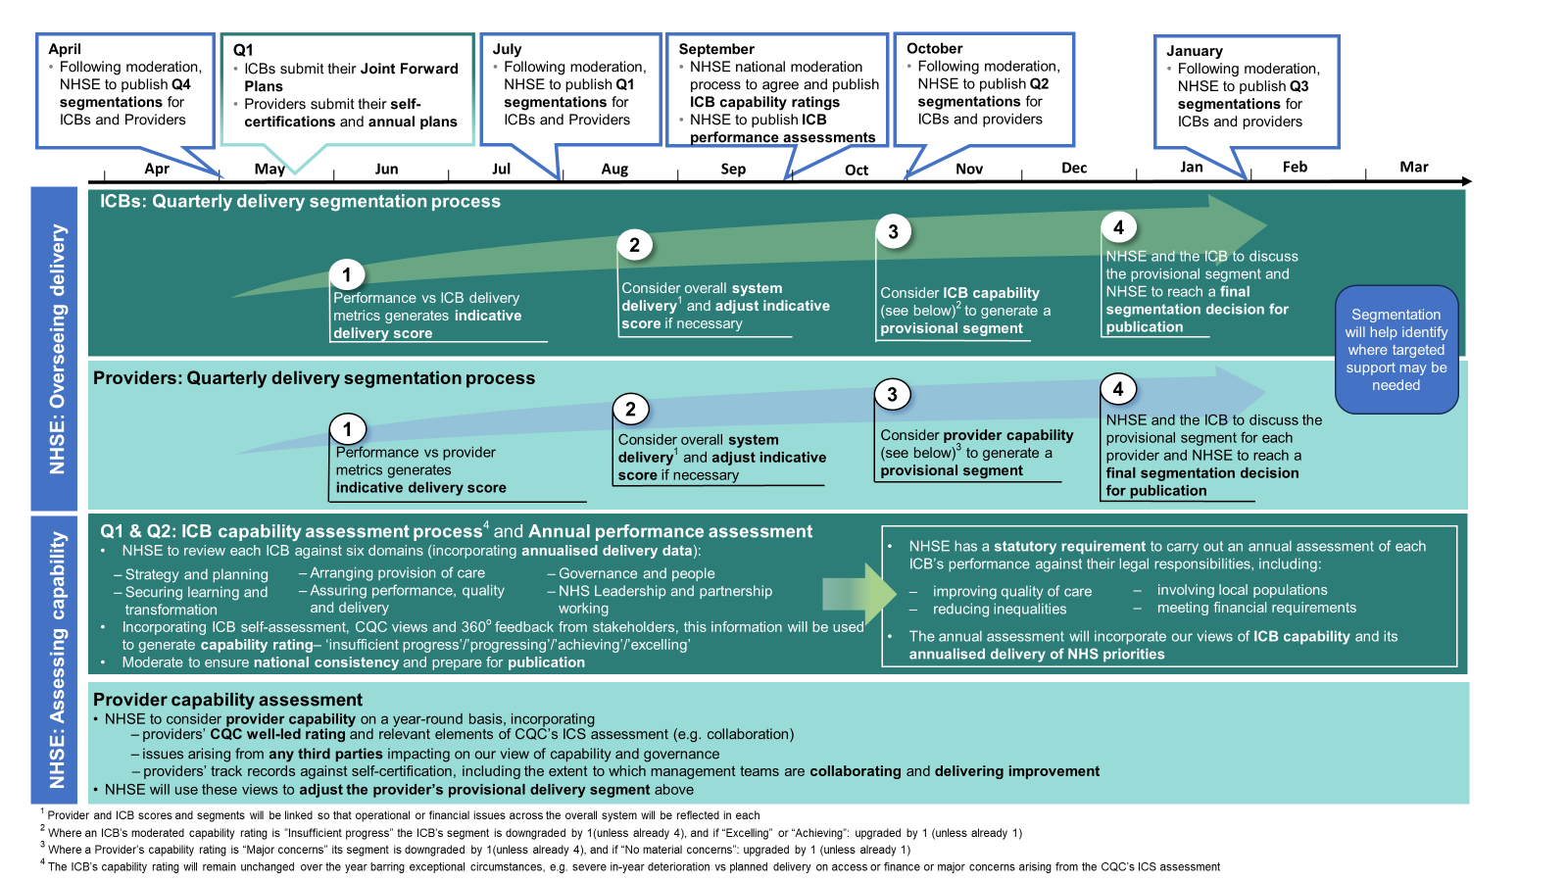

Figure 5: overall oversight elements

Figure 5 sets out a summary of the oversight and assessment approach on a single page. This includes both the ICB and Provider quarterly delivery segmentation process, (segmentation will help identify where targeted support may be needed), and the ICB capability assessment and annual performance assessment process.

* **Annual oversight process for ICBs and providers:**
  + In Q1, ICBs submit their Joint Forward Plans, Providers submit their quarterly self-certifications and annual plans, and in April, NHSE publishes segmentation for ICBs and Providers for previous quarter following moderation
  + In Q2 July, Providers submit their quarterly self-certifications and NHSE publishes segmentation for ICBs and Providers for previous quarter following moderation, NHSE national moderation process takes place to agree and publish ICB capability ratings and NHSE also publishes ICB performance assessments.
  + In Q3, Providers submit their quarterly self-certifications, NHSE publishes segmentation for ICBs and Providers for previous quarter following moderation
  + In Q4 January, Providers submit their quarterly self-certifications, NHSE publishes segmentation for ICBs and Providers for previous quarter following moderation
* **ICB quarterly delivery segmentation process:**
  + Performance on key metrics generates indicative delivery score (1-4, where 1 is best)
  + NHSE will consider overall system delivery (provider and ICB scores and segments will be linked so that access or financial issues across the overall NHS system will be reflected in each) and adjust indicative score, if necessary
  + NHSE will consider ICB capability and adjust segment, if necessary to generate a provisional delivery segment (where an ICB's moderated capability rating is 'insufficient progress' the ICB's segment is deteriorated by 1 (unless already a 4) and where the capability is 'Excelling' or 'Achieving' the ICB's segmented is improved by 1 (unless already a 1))
  + NHSE and the ICB to discuss the provisional segment for each provider and NHSE to reach a final segmentation decision for publication
* **Provider quarterly delivery segmentation process:**
  + Performance on key metrics generates indicative delivery score (1-4, where 1 is best)
  + NHSE will consider overall system delivery (provider and ICB scores and segments will be linked so that access or financial issues across the overall NHS system will be reflected in each) and adjust indicative score, if necessary
  + NHSE will consider provider capability and adjust segment if necessary to generate a provisional delivery segment (where a provider’s capability rating is ‘Major concerns, its segment is deteriorated by 1 unless it’s already a 4, where a provider’s capability rating is ‘No maternial concerns’, its segment is improved by 1 unless it’s already a 1)
  + NHSE and the ICB to discuss the provisional segment for each provider and NHSE to reach a final segmentation decision for publication
* **ICB annual assessment and capability assessment processes over quarters 1 and 2**
  + NHSE to review each ICB against six functional areas incorporating delivery data, i.e. strategy & planning, arranging/provision of care, governance and people, securing learning and transformation, assuring performance, quality and delivery, and NHS leadership and partnership working
  + Incorporating ICB self-assessment, CQC views and 360 degree feedback from stakeholders, this information will be used to generate a capability rating i.e. 'insufficient progress', 'progressing', 'achieving', or 'excelling'
  + Ratings are moderated to ensure national consistency
  + The ICB's capability rating will remain unchanged over the year barring exceptional circumstances, e.g. severe in-year deterioration on planned delivery, access, finance, or major concerns arising from the CQC's ICS assessment
  + NHSE has a statutory requirement to carry out an annual assessment of each ICB's performance against their legal responsibilities, including improving quality of care, involving local populations, reducing inequalities, and meeting financial requirements.
  + The annual assessment will incorporate our views of ICB capability and delivery of NHS priorities
* **Annual capability assessment process for Providers**
  + NHSE to consider provider capability incorporating providers' CQC well-led rating and relevant elements of CQC's ICS assessment (e.g. collaboration), issues arising from any third parties impacting on our view of capability and governance, and providers' track records against self-certifications, including the extent to which management teams are collaborating and delivering improvement to generate a capability rating i.e. ‘No material concerns’, ‘Some concerns’, and ‘Major concerns’
  + NHSE will use these view to adjust the provider's delivery segment
  + The provider’s capability rating will remain unchanged over the year barring exceptional circumstances, e.g. severe in-year deterioration on planned delivery, access, finance, or major concerns arising from the CQC assessments
  1. Monitoring

1. As part of NHS England’s oversight process, we monitor and gather insights across the oversight domains. The information collected and reviewed includes both quantitative data (including but not limited to the defined oversight metrics) and qualitative information. Qualitative information may include that derived from ICBs and providers as part of routine conversations, reports from other regulators such as the CQC including its upcoming ICS assessments, any formal reporting documents such as the outcomes of the System Quality Group, as well as other relevant information including that provided by third parties such as through 360-degree feedback, peer reviews, or formal publications/assessments.
2. Alongside, we work with key regulators including CQC, the Health and Care Professions Council, the General Medical Council and the Nursing & Midwifery Council through the national and regional Joint Strategic Oversight Group (JSOG) to provide a dedicated space for regulators to share intelligence and develop aligned approaches to support organisations.
3. We hold regular review meetings with ICBs and, where appropriate, providers to discuss emerging issues and track progress against any agreed improvement plans. The expectations for the membership, scope, and frequency of these meetings are set out in Table 2. Ongoing regular meetings may be complemented by focused engagement and escalation where specific challenges emerge, or where an organisation is in the Recovery Support Programme.

|  |  |
| --- | --- |
| **Scope** | |
| **ICB**   * ICB’s unique contribution to overall system performance and quality and delivery against the four purposes of an ICS * Effectiveness of current support or intervention arrangements of ICB and its provider partners and the extent to which these may need to be refined. * The extent to which NHS system partners are working effectively together to deliver and improve. * Assurance of commissioning and delivery of delegated services, including but not limited to Primary, Optometry, Dental, and certain Specialised services. | **Provider**   * Oversight of and support or intervention to: * individual organisations, including those that span multiple ICSs e.g. ambulance providers and specialist providers. * collaboratives that span multiple places, including for the delivery of specialised services * Place-based partnerships. * Scope is determined by the specific issues identified in discussion between NHS England and ICB leadership |
| **Roles and participation** | |
| **ICB**   * Led by NHS England with: * ICB leadership team * Relevant national experts * By exception senior leaders from NHS system/ providers/ organisations where there are specific concerns regarding their organisations * For organisations in the Recovery Support Programme, these meetings are led by the National programme team. | **Provider**   * Led by the ICB in line with arrangements set out in the ICB’s governance handbook. * May involve NHS England in situations where: * We have concerns regarding a provider being in breach or potential breach of their license conditions. * The ICB has requested expert support from us. * The provider is in segment three or four. * The ICB has a capability rating of progressing or insufficient progress |
| **Frequency of review meetings** | |
| * The meeting frequency will vary according to the governance arrangements agreed between our regional team and ICB, but is expected to be at least quarterly; * We may engage more frequently where there are material concerns or where the RSP is involved; * An annual meeting linked to ICB’s capability assessment. | * The meeting frequency will vary according to the governance arrangements agreed between our regional team, ICB, and provider leadership but is expected to be at least quarterly; * We may engage more frequently where there are material concerns or the RSP is involved. |

Table 2: Ongoing monitoring process – review meetings

4.2 Identifying the scale and nature of support or intervention needs

1. Each ICB and provider is assigned a segment between 1 and 4 indicating their respective level of delivery and support needs. We make decisions on segments by considering these specific elements:
   * + - 1. A set of objective, measurable criteria based on metrics associated with the six domains of the oversight framework;
         2. A set of additional considerations, including the aggregated NHS system performance on key national priorities such as Urgent and Emergency Care, Elective Care, Mental Health care, and finance;
         3. The capability of the organisation to improve without additional support or intervention; and
         4. A consideration of the organisation’s improvement trajectory along with the role it is playing in supporting its NHS system partners in meeting shared priorities. We also consider whether challenges are long-standing and how the organisation is working to address them.
2. Primary care providers, primary care networks (PCNs), and other non-trust providers or bodies such as provider collaboratives are not allocated their own segments. These entities do, however, contribute to the ICB’s segment and the overall system performance.

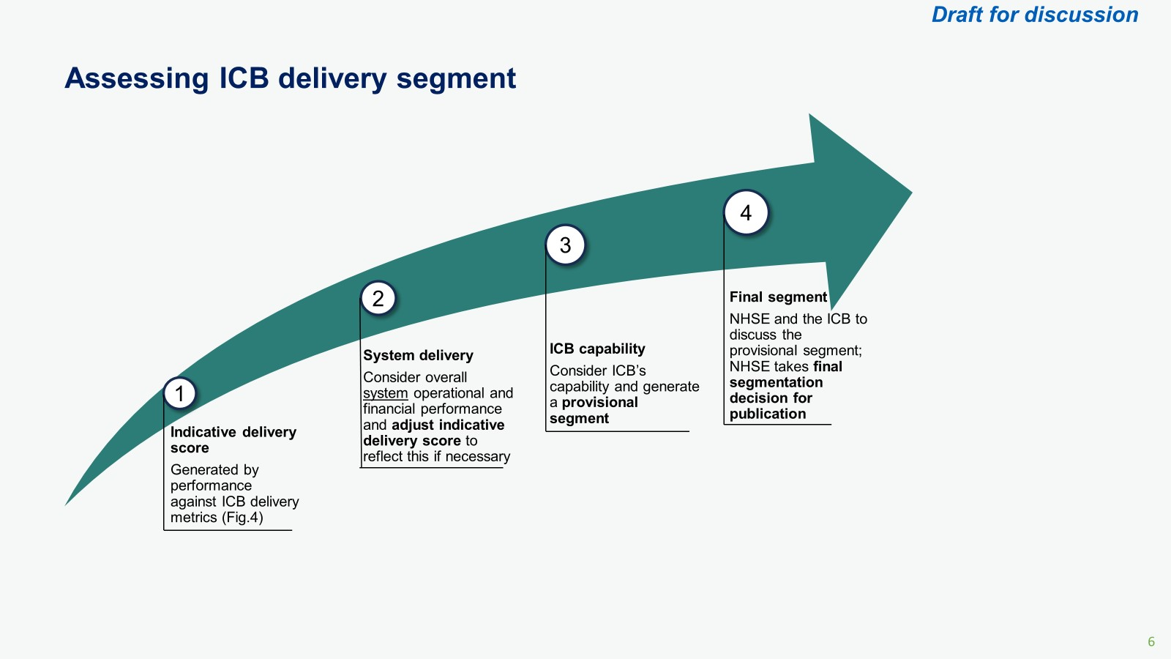

Figure 6: Determining the ICB segment

1. Indicative delivery scores are determined through a metric-driven process based on a range of measures linked to the unique contribution of the ICB or provider to the specified oversight domains. The metrics that are used to give this initial score are reviewed on an annual basis to ensure they reflect the latest published NHS priorities. For transparency, the list of metrics being used to guide segmentation is made publicly available on our website and will include consideration for any assessments by CQC.
2. Each metric is individually scored and contributes to a specific “domain” score, domain scores are then brought together to form the indicative delivery score. As well as demonstrating relative delivery performance we will also provide detail on overall direction-of-travel in order to recognise those organisations that are improving, maintaining or declining in delivery terms.
3. The indicative delivery score of an individual ICB or provider is moderated to consider the wider performance and delivery of the NHS system through consideration of additional criteria. These criteria include the NHS system’s financial stability and performance against key national priorities. This is to ensure that consideration is given to shared priorities for which both ICBs and providers have a role to play in achieving. This results in a provisional delivery score for the organisation (see Figures 6 and 7 ).

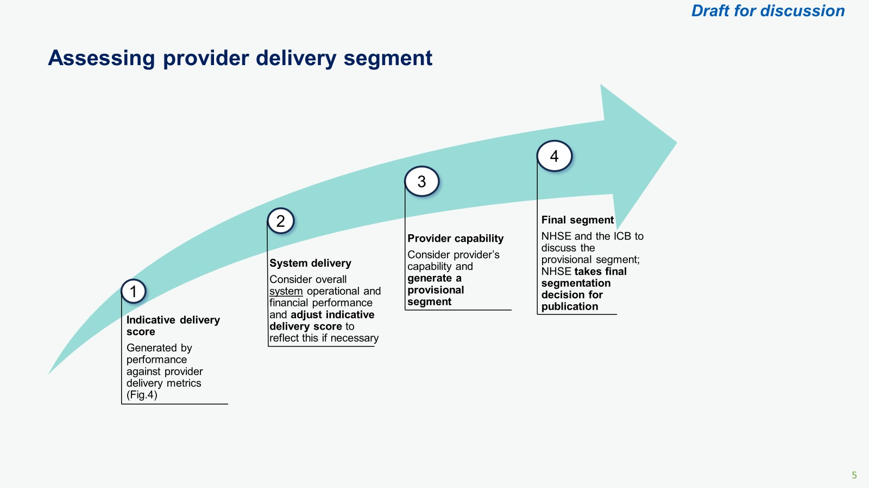

Figure 7. Determining the provider segment

1. The provisional delivery score will then be translated into a “segment”. This segment is determined by taking the provisional delivery score and considering the capability of the provider or ICB to address delivery performance issues, its improvement trajectory, the role it is playing in supporting its broader NHS system partners, and whether challenges are complex and long-standing. The capability for ICBs includes consideration of their annual capability ratings (see section 5.2) and for providers this includes a view of their capability (see section 5.3). Where an organisation has high levels of capability their segment may be higher than their provisional delivery score suggests, to recognise the confidence in the organisation to address the issues identified. Equally where capability is lower the segment may be lower than the provisional delivery score.
2. The provisional segment will be considered through our governance structures to ensure that the decision is robust, proportionate and defensible. Once we are satisfied with the final segmentation decision this decision is officially conveyed to the organisation and published on our website.
3. Segments are reviewed at least quarterly as part of a review meeting but can be updated at any time based on emerging information. For individual providers, their ICB may make recommendations on segments based on an evaluation of support or intervention needs and confidence in plans to deliver improvement. We will consider the advice from the ICB but we are responsible for making the final decision on the segment and taking enforcement action if this is required.
4. ICBs and providers that are situated in a high-functioning NHS system and have no specific needs or challenges are likely to be assigned a segment of 1 or 2. ICBs and providers that are assigned a segment of 1 are expected to offer peer-to-peer support and share best practices with other organisations to support collective improvement.
5. Providers and ICBs that have complex and/or serious challenges and support or intervention needs, or those operating within challenged NHS systems requiring a coordinated system-wide response are likely to be assigned segments of 3 or 4, depending on the scale and nature of the challenges. They may be subject to enforcement action, enhanced oversight and, depending on the nature of the problem(s) identified, additional reporting requirements and financial controls may be introduced.

|  |  |  |  |  |
| --- | --- | --- | --- | --- |
| **Segment** | **Description** | **How we will support** | **How we will drive improvement** | **How we will intervene** |
| 1 | Consistently high-performing across domains, delivering against plans and operating in a high-functioning NHS system. Has a track record of successful delivery or effective recovery. | No Specific support or intervention needs are identified. Expected to offer peer support to others or support the development of best practice tools. | Will work alongside us to develop best practices and improvement initiatives in areas in which the organisation excels. May be asked to work with us to provide expert challenge to other organisations. | The use of our enforcement powers is not compatible with this segment. Where enforcement action is required, the organisation will be assigned a delivery segment of 2 or more. |
| 2 | Developing with confidence in the ability to improve further and operate in a high-functioning NHS system. Specific issues exist with plans in place that have the support of system partners. | The organisation can diagnose and clearly explain its support needs which will be predominantly supplied locally. Our support on specific issues is provided where appropriate. | Will work with us to support the development of best practices in areas of high performance. Targeted support aimed at improving specific pathways where issues have been diagnosed. | Due to the relatively high-performing nature of the organisation and its level of maturity, the use of enforcement powers will not be common but may be used where specific issues call for this approach. |
| 3 | ICB or provider and/or wider system are significantly off-track in a range of areas. We lack confidence in the capability to respond to challenges without support. | Support needs are diagnosed together and delivered through local support offers, defined national support programmes and bespoke regional interventions. | Receives enhanced scrutiny targeted at delivering improvement in the most challenged performance areas. Recovery KPIs and trajectories are agreed and proactively monitored. | We may apply interventions and/or direct an organisation to take specific actions related to diagnosed issues. Enforcement action may be taken where required. |
| 4 | There is a serious failure of patient safety, quality, finance, leadership, or governance or the ICB or provider and NHS system face serious, long-standing and complex issues requiring intensive co-ordinated response | The Recovery Support Programme supports the ICB or provider to undertake a full diagnostic to identify support needs and develop a full recovery plan in collaboration with system partners | We appoint an Improvement Director to intensively support the organisation to meet improvement goals. Intensive scrutiny to ensure delivery of the agreed recovery plan and meet improvement criteria to transition to segment 3. | Entry into the Recovery Support Programme and possible use of enforcement powers is agreed through relevant executive governance. Transition out of Recovery Support Programme into segment 3 requires transition criteria to be met. |

Table 3: Segment definitions and expectations

* 1. Implementing support or intervention activity

1. We provide direct support or intervention where:

an ICB or provider has been assigned a delivery segment of 3 or 4, or if there is significant underperformance of a key national priority;

an ICB or provider does not have the necessary capability to lead the requisite improvement;

improvement is not being seen at the pace or scale required; or

there has been a serious failure of governance, leadership, finance, quality, or patient safety, or there are long-standing challenges.

1. All organisations may benefit from the universal support offered under our [NHS IMPACT programme](https://www.england.nhs.uk/nhsimpact/). NHS IMPACT supports delivery of clinical and operational excellence, both by helping to develop the leadership and organisational capacity, capability and infrastructure to create the conditions for improvement, and delivering a small number of programmes to drive adoption and local adaptation of operational processes and clinical pathways that are proven to improve quality and productivity.
2. ICBs and providers with segments of 2 may receive support or intervention on specific areas of concern.
3. Where an ICB or provider is assigned a segment of 3, NHS England regional teams work with the ICB or provider (for providers this also includes their relevant ICB) and agree on the ‘improvement criteria’ that must be met as part of the support or intervention. These criteria and the planned timeline to achieve them are recorded and form part of the regular review discussions.
4. Our most intensive support intervention of the Recovery Support Programme is reserved for ICBs and providers with a segment of 4. For these organisations, the ‘improvement criteria’ are agreed with the programme team and they receive direct support from an improvement director to meet those criteria. These organisations may be subject to enforcement action and leave the programme when the improvement criteria have been met in a manner deemed sustainable by the relevant regional and Recovery Support Programme teams. The NHS system partners of these organisations will be expected to provide support where improvements require system-wide action and may also be considered for formal intervention where required. An overview of the Recovery Support Programme is set out in Annex C.
5. Any support or interventions an ICB or provider is receiving are examined as part of regular review meetings to determine whether they are having the desired impact or whether the approach requires adaptation. For organisations in the Recovery Support Programme, this review of support or interventions takes place at escalation meetings and any change in improvement criteria, planned timelines, or support has to be agreed through the relevant executive governance.
6. In some circumstances we may determine that it is necessary to invoke formal powers of enforcement in response to an identified issue. The [NHS Enforcement Guidance](https://www.england.nhs.uk/publication/nhs-enforcement-guidance/#:~:text=This%20guidance%20outlines%20how%20NHS,licensed%20independent%20providers%20of%20NHS) contains further details on the circumstances and procedures for taking any such action.

### 4.4 High-performing organisations

1. High-performing organisations may have access to flexible improvement resources and national leadership opportunities, including taking a role in policy formation with NHS England.
2. Assessment
   1. ICB Annual Performance Assessment
3. NHS England has a legal duty[5] to annually assess the performance of each ICB in respect of each financial year and publish a summary of its findings.
4. The assessment must consider how well the ICB has discharged its functions and include, but not be limited to, how effectively the ICB has discharged the following specific duties, required under the terms of the Act:
   * + the duty as to improving the quality of services
     + the duty as to reducing inequality of access and outcome
     + the duty to obtain appropriate advice
     + the duty to facilitate, promote and use research
     + the duty to have regard to the effect of decisions (The “triple aim”)
     + the duty to make arrangements to involve patients, carers and the public in commissioning plans and decisions that affect them
     + the ICB’s financial duties
     + the duty to have regard to certain wider local needs assessments and strategies.
5. As of 2024/25, our annual performance assessment of ICBs in respect of the preceding year will include consideration of the following:
6. An annualised delivery score resulting in a segment of 1-4 (see section 4.2); and
7. A capability rating based on how well the ICB has performed activities under six core functional areas over the year (see section 5.2. The capability assessment will also include how the ICB has performed its functions as required in the NHS Act 2006).
8. In quarter two of each financial year, NHS England will hold a meeting with each ICB dedicated to discussing their annual performance assessment for the preceding year. As part of this meeting, we will discuss the outcome of our capability assessment in respect of the previous year, reflect on existing and emerging issues, and invite the ICB to make any representations that it feels are appropriate.
9. Alongside the capability assessment we will also summarise our views of the ICB’s overall delivery taking into consideration the segment for Q1, performance over the previous year, as well as reflecting on overall delivery against national objectives.
10. The ICB’s capability rating and segment for the previous year will then be agreed upon by the relevant NHS England governance group and formally communicated to the ICB’s Chair and CEO in a letter from the relevant Regional Director. This letter will, in addition to the headline findings, contain a summary report that outlines areas in which the ICB has performed strongly and could support others as well as any identified areas for development and any subsequent support we will provide in the year ahead. The letter will also detail the agreed ways of working between us and the ICB[6]. This will include, but may not be limited to:
    * + - 1. How we will work with the ICB to oversee providers in that NHS system,
          2. How the commissioning of delegated services will be overseen, and
          3. How we will support the ICB to oversee delivery of key operational and forward plans.
11. If an ICB or provider is entering the Recovery Support Programme, it will receive a letter from the relevant NHS England national executive.
12. ICB Boards will be asked to publish their annual assessments alongside their annual report and accounts as part of a public meeting while NHS England will publish a summary of all annual assessments as required by The Act.
    1. ICB Capability Assessment
13. We have described six broad functional areas in Table 5 with several supporting activities (outlined in Annex A), that ICBs undertake which assures us that they are delivering their contribution to the four purposes of an ICS and have effectively discharged, and will continue to discharge, their statutory duties and powers. Our assessment of ICBs will be based on these six functional areas. Each functional area requires a high level of expertise within the ICB and a collaborative approach to working with local partner organisations.

|  |  |
| --- | --- |
| **Area** | **Criteria** |
| **Strategy & Planning** | Developing strategies with the ICP and agreeing plans with providers and partners that are based on the assessed need of the population health and will improve health outcomes. |
| **Leadership of the NHS and partnership working** | Building strong partnerships and effective governance arrangements with organisations and stakeholders in the ICS which enable organisations to work together to deliver agreed plans |
| **Arranging for the provision of care services (commissioning)** | Agreeing and allocating resources to providers.  Working in collaboration to design and plan for the provision of services (including for delegated commissioning functions). |
| **Assuring performance, quality and delivery** | Ensuring that providers deliver against agreed ambitions and spending limits.  Ensuring that appropriate response is in place to address risks to delivery. |
| **Securing transformation and learning** | Driving system-wide transformation of services, workforce, data, digital and estates and enabling service quality improvement. |
| **Effective governance and people** | Ensuring that the ICB is an effective and well-run organization with a high performing board, robust governance and healthy workforce and culture. |

Table 5: Functional areas for ICB Capability assessment

1. We will undertake an annual capability assessment of each ICB as part of the Annual Assessment Process (see section 5.1). These may be reviewed and updated in-year if there is a significant change in circumstance.
2. Figure 8 provides an overview of the process through which an ICB capability assessment will be determined.

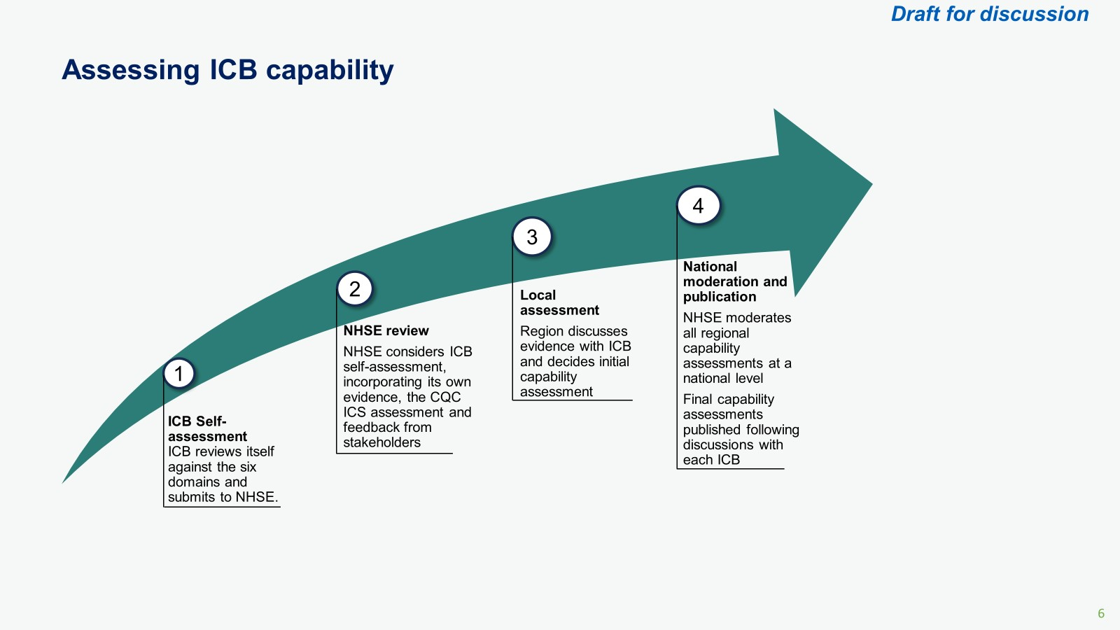

Figure 8: The ICB capability assessment process

1. The capability assessment will result in a capability rating as outlined in Table 6. The single word rating will be determined by the ratings given to each functional area. Once finalised, these will then be published alongside a narrative description of how the rating decision was reached, including highlighting areas of good practice and areas where further improvement may be required. This narrative will also support leadership teams in appraising and self-assessing in line with the expectations of the NHS Leadership Competency Framework.
2. We will use the ICB’s capability rating to inform our final decision on an ICB’s segment and associated support or intervention needs.

|  |  |  |
| --- | --- | --- |
| **Rating** | **Rating description** | **Potential support or interventions** |
| Excelling | The ICB can demonstrate it fully delivers/excels against all key lines of enquiry outlined under each activity | No Specific support or intervention needs are identified. Expected to offer peer support to others or support the development of best practice tools. |
| Achieving | The ICB can demonstrate it fully delivers against most of the key lines of enquiry under each activity (with partial delivery against some) | Limited support or intervention required. Support on specific issues may be provided where appropriate. |
| Progressing | The ICB can demonstrate partial delivery of all key lines of enquiry under each activity or full delivery of a small number | We work in partnership with the ICB to oversee the providers in the ICS. Bespoke regional support may be provided to develop capability. |
| Insufficient Progress | The ICB has not demonstrated, or cannot currently demonstrate, delivery against the key lines of enquiry / can only demonstrate partial delivery of some key lines of enquiry under the activities | We work in partnership with the ICB to oversee the providers in the ICS. We may consider entry of the ICB into the Recovery Support Programme if we are sufficiently concerned. |

Table 6: ICB Capability Ratings

5.3 Evaluating Provider Capability

1. The NHS provider licence sets specific requirements on trust governance, including the ability to deliver national priorities, maintaining standards of organisational and quality governance, and collaborating effectively with system partners.
2. To reflect this, we will consider provider capability when allocating them a segment. This will incorporate, for a given provider:
   1. its CQC well-led rating;
   2. issues uncovered following any relevant third-party information; and
   3. the boards’ organisational awareness and track record of delivery.

**CQC well-led rating**

1. The CQC introduced its well-led ratings for providers in 2014 and, following its latest iteration, this continues to be an important element of how we evaluate the capability of providers and their management.

**Relevant third-party information**

1. Issues in recent years demonstrate the importance of capturing and responding to third-party information that may highlight issues at providers. As a result, we will consider the results of any investigations arising from information received from sources including:
   1. other regulators, such as the Health & Safety Executive, the Information Commissioner and Human Tissue Authority;
   2. professional medical and clinical bodies, such as the GMC, NMC and Royal Colleges;
   3. information from the ICB and CQC ICS reviews which may flag any collaboration issues; and
   4. clinical and cultural issues e.g. coroners, trends in whistleblowing, Freedom To Speak Up (FTSU) reports.

**Board self-certification and organisational awareness**

1. Provider Boards represent the first line of oversight and assurance. To reflect this, support a level of organisational responsibility, collaboration with system partners, and commitment to continuous improvement at provider boards, we will require boards as part of their annual planning returns to self-assess against specific areas on behalf of their organisation. These areas will include strategy, quality, people, access, productivity and finance. A full list of the proposed criteria by area can be found in Annex B.
2. We will use the self-certification both prospectively and retrospectively:
   * + - 1. Where providers cannot certify against these requirements, we will seek to understand the reasons why and planned actions to address this; and
         2. Subsequent delivery (or not) against these will inform our and the relevant ICB’s views of management teams and any support or development needs[7].

Where issues arise, NHSE and/or the ICB will to follow up with trusts to consider:

* the extent to which the provider was aware of the issue;
* the robustness of plans to address it and management’s ability to do so; and
* the subsequent delivery of plans to address the issue.

1. Where circumstances change in-year and a trust can no longer meet its certification in its annual plan submission, Boards will by exception be expected to inform both us and their ICB.
2. We will use the information above to inform our final decision of a provider’s segment and associated support or intervention needs. For example, where a provider shows strong capability through its CQC well-led rating, self-certification and track record, this may uprate the segment given the evidence supporting the provider’s ability to address concerns. Conversely, reduced capability evidenced through this process could downrate the segment indicating the need for support or intervention to address the challenges.

## 

## Annex A: ICB functional areas and supporting activities

The ICB capability assessment will include undertaking an assessment of how well an ICB has performed and is performing its statutory functions, by looking at the supporting activities in each of the six functional areas outlined in the table below. For each activity NHS England will assess how an ICB is performing the statutory functions involved in carrying out that activity, including an assessment of the discharge of relevant specific duties. Functional

|  |  |  |
| --- | --- | --- |
| Functional area | Supporting activity | Supporting activity description |
| **A – Strategy and Planning** | **Assessing need** | Intelligence and analytical capabilities and infrastructure will be developed to generate insight into current and future population health needs. This insight is used to ensure that strategies and plans are targeting the areas that will make the biggest difference to improving outcomes and reducing inequalities.  **Including an assessment of how the following relevant duties have been discharged:**   * **Duty as to reducing inequality of access and outcomes** * **Duty to address the particular needs of victims of abuse** * **Duty to address the particular needs of children and young persons.** |
| **Strategy** | An Integrated Care Strategy that has been agreed with ICBs, local authorities and other partners in the Integrated Care Partnership. The strategy considers the assessed need of the population, confirms the shared priorities between partners and sets out how the wider partnership will align its actions to meet the needs of its population and reduce inequalities. The ICS Strategy and Health and Wellbeing Strategies will be used by ICB and partner NHS Trusts and Foundation Trusts to inform planning. |
| **Planning** | A five-year Joint Forward Plan (JFP) agreed between ICBs and partner NHS trusts and foundation trusts that sets out how they all will exercise their functions over the next five years to deliver against local strategies and national priorities. The JFP looks to address the health needs of the population, sets out the activities required to deliver it, who is responsible for these, the phasing of these activities, monitoring requirements and financial management arrangements. This plan will include how ICBs will arrange for the provision of care services and the agreed role that providers will have in transforming services to achieve outcomes in the plan. JFPs will be updated annually, informing operational plans that set out in greater detail actions to be taken for delivery by the ICB and partner trusts. The ICB and its partner trusts/FTs will also agree a capital plan that underpins the delivery identified in the JFP.  **Including an assessment of how the following relevant duties have been discharged:**   * **Duty to have regard to joint strategic needs assessments, integrated care strategies and local Health and Wellbeing strategies** |
| **Involving and engagement** | There is comprehensive engagement of a range of voices on system plans and strategies, including public, patient and carer views, clinical and care professional expertise and advice (including through clinical networks) and the wide range of partner and provider perspectives including the voluntary sector, Healthwatch and partners beyond health.  **Including an assessment of how the following relevant duties have been discharged:**   * **Duty to promote the involvement of each patient** * **Duty to involve patients, carers and the public in decisions about the planning, development and operation of services commissioned and provided** * **Duty to obtain appropriate advice.** |
| **B – Leadership of the NHS** | **Leading the NHS** | ICBs are recognised as the local leaders of the NHS. They have established and provide ongoing support to joint working arrangements with NHS and wider system partners that embed collaboration as the basis for delivery. ICBs are aware of the strengths and development needs of partner organisations.  **Including an assessment of how the following relevant duties have been discharged:**   * **Duty to promote the NHS constitution** * **Duty to promote integration** |
| **Mutual accountability** | There are clear and explicit governance arrangements and effective decision-making structures between partner organisations for whole-system delivery and performance to deliver the Integrated Care Strategy, JFP including the ICB commissioning plan, system financial position and capital plan effectively.  **Including an assessment of how the following relevant duties have been discharged:**   * **Duty to promote the NHS constitution.** |
| **Influencing** | ICBs build rapport and understanding with partners and community leaders to ensure that the NHS plays a full part in influencing the wider determinants of health such as social and economic development and environmental sustainability in a way which improves health outcomes..  **Including an assessment of how the following relevant duties have been discharged:**   * **Duty to promote integration** * **Duty in respect of climate change.** |
| **C - Arranging for the provision of healthcare services (strategic commissioning)** | **Allocating resources** | The ICB and its partners (provider collaboratives and place based partnerships) effectively plan for the allocation of resources based upon a shared and granular understanding of the current and planned future use of the ICB's budget to meet population health needs. Plans utilise appropriate cost and payments data and in agreeing future resource allocation, they consider available data on unwarranted variation in unmet need, outcomes, the use of resources and good practice care models. |
| **Shaping the design of services and service provision** | ICBs work in in collaboration with patients, clinicians, and system partners (provider collaboratives and place based partnerships) to design and plan for the provision of services (including for delegated commissioning functions) for all population groups, delivering the right care, at the right time and in the right place to meet identified needs. Investment is used to shape the provision of care services to ensure that there are sufficient services to meet both current and future projected demand, provide choice, drive quality improvement and secure the desired health outcomes.  **Including an assessment of how the following relevant duties have been discharged:**   * **Duty as to patient choice** * **Duty to involve patients, carers and the public in decisions about the planning, development and operation of services commissioned and provided** |
| **Procuring and contracting for the provision of services** | Effective procurement of hospital, community and mental health NHS services in line with the Provider Selection Regime, and NHSE frameworks and standards, as well as services where NHSE has delegated commissioning responsibility. |
| **D – Assuring performance, quality and delivery** | **Delivery of assurance and oversight** | There are clear arrangements for assurance of delivery for individual organisations and across the system as a whole. ICBs hold all providers they commission – including IS – to account for quality and performance, securing ongoing assurance that the provider can meet these requirements.  To reinforce commitment to system-wide (rather than single organisation) approaches to improvement, ICBs act as the first line of oversight for partner trusts/FTs apportioned to them for financial control purposes  (including determination of with and through) as agreed with NHS England. ICBs and partner trusts/FTs hold one another to account through the mutual accountability arrangements for the delivery of their shared JFP and Capital Plan and national priorities as set by NHS England.  **Including an assessment of how the following relevant duties have been discharged:**   * **Duty as to improvement in the quality of services.** |
| **Improvement** | There is an approach to improvement that ensures that all NHS organisations are jointly responsible for improving outcomes across pathways of care, ICBs hold a system wide understanding of the drivers of performance issues and work to enable improvement across the system. |
| **Financial management** | All NHS organisations work to ensure overall system financial balance and do not act to improve their own financial position at the expense of a system partner. ICBs ensure that their annual budget, revenue limits and running cost allowance are not exceeded. They ensure that there is 'grip' across the system by holding partners to account for NHS spending across the system in line with NHSE guidance and actively engage key stakeholders on financial performance and delivery of the shared capital plan, using mutual accountability arrangements.  **Including an assessment of how the following relevant duties have been discharged:**   * **Financial duties** * **Duty to operate with effectiveness, efficiency and economy.** |
| **Emergency response** | There are robust plans in place for emergency planning and response. ICBs plan for, respond to, and lead recovery from incidents (EPRR), to ensure NHS and partner organisations are joined up at times of greatest need, including incident coordination responsibilities. |
| **E – Securing transformation and learning** | **Workforce** | There is a system-wide approach to workforce and people planning. ICBs lead the implementation of the NHS Long Term Workforce Plan.  **Including an assessment of how the following relevant duties have been discharged:**   * **Duty to promote education and training.** |
| **Digital** | Digital solutions are delivered at scale where appropriate and innovative approaches are tested and spread across systems. ICBs lead system-wide action on digital, working across the partnership to put in place smart digital and data foundations to connect health and care services and ultimately transform care to put the citizen at the centre of their care. |
| **Data** | Joined-up data and digital capabilities are used to understand local priorities, track delivery of plans, monitor and address variation and drive continuous improvement in performance and outcomes. ICBs ensure there is a system-wide approach to developing analyst capability and capacity. |
| **Infrastructure** | Driving joint work on estates, procurement, supply chain and commercial strategies to maximise value for money across the system and support the wider goals of development and sustainability. |
| **Learning** | The ICB board embeds learning at all levels of the system, including supporting the implementation of NHS IMPACT, and supporting research and innovation. Leaders implement relevant or mandatory quality frameworks, recognised standards, best practices or equivalents to improve equity in experience and outcomes for people using services and tackle known inequalities.  **Including an assessment of how the following relevant duties have been discharged:**   * **Duty as to reducing inequality of access and outcome** * **Duty to facilitate, promote and use research** * **Duty to promote innovation.** |
| **F – Effective governance and people** | **Risk management** | The ICB uses board assurance frameworks and other tools to identify and manage risks to ICB delivery. They ensure system-wide risk management arrangements are also in place (in particular addressing quality) to address shared risks.  **Including an assessment of how the following relevant duties have been discharged:**   * **Duty as to the improvement in the quality of services.** |
| **Board capability** | ICB CEO and Chair to ensure that the ICB board has the skills and capability to lead the system. High-quality leadership is sustained through safe, effective and inclusive recruitment and succession planning.  **Including an assessment of how the following relevant duties have been discharged:**   * **Duty to keep experience of members under review.** |
| **Effective decision making** | The ICB board uses timely, robust and relevant information on organisational performance across the system, and divides its time evenly between in-year and strategic discussions.  **Including an assessment of how the following relevant duties have been discharged:**   * **Duty to take appropriate advice** * **Duty to have due regard to the wider effect of decisions (the triple aim)** * **Duty to involve patients, carers and the public in decisions about the planning, development and operation of services commissioned and provided** |
| **Healthy culture** | The ICB board demonstrates positive behaviours that promote an open, safe and compassionate culture within the organisation that allows individuals to speak up as necessary and ensures that the ICB reflects the diversity of its population. |

## Annex B: Proposed annual self-certifications for providers

|  |
| --- |
| **The Board confirms that:** |
| **Strategy** |
| * The organisation's strategy reflects shared priorities across the system and has an agreed contribution to the Joint Forward Plan and Capital Plan with ICB and system partners. * The organisation is meeting, and will continue to meet, any regulatory directions placed on it or undertakings. * The trust is working effectively and collaboratively with system partners and its provider collaborative for the overall good of the system and population served. |
| **Quality of Care** |
| * Having had regard to relevant NHSE guidance (supported by Care Quality Commission information, its own information on serious incidents, patterns of complaints, and including any further metrics it chooses to adopt), the trust has, and will keep in place, effective arrangements for the purpose of monitoring and continually improving the quality of healthcare provided to its patients. * Systems are in place to monitor patient experience, and there are clear paths to relay safety concerns to the Board. |
| **People** |
| * Staff feedback is used to improve quality of care provided by the trust. * Staff have the relevant skills and capacity to undertake their roles, with training and development programs in place at all levels. * Staff are able to express concerns in an open and constructive environment. |
| **Access** |
| * Plans are in place to improve performance against the relevant access and waiting times standards. * The trust is able to identify and address inequalities in access/waiting times to NHS services across its patients. * Appropriate population health targets have been agreed with the Integrated Care Board. |
| **Productivity** |
| Plans are in place to deliver productivity improvements as referenced in e.g. the NHS model system guidance, The Insightful Board and other guidance as relevant. |
| **Finance** |
| * The trust has a robust financial governance framework and appropriate contract management arrangements. * Financial risk is managed effectively and financial considerations (e.g. efficiency programs) do not adversely affect patient care and outcomes. * The trust actively engages with its system partners on the optimal use of NHS resources and supports the overall system delivering its planned financial out-turn. |
| **The Board confirms that it has not received any relevant third-party information contradicting or undermining the information underpinning the disclosures above.** |

## Annex C: Recovery Support Programme

* + - * 1. The Recovery Support Programme (RSP) was launched in 2021 to provide focused integrated support to the most challenged ICBs and providers (NHS Trusts and Foundation Trusts). It has been developed to provide intensive support at either the organisational level, working with the relevant ICB as appropriate, or across the whole health and social care system, working with non-NHS partners where necessary and coordinating support through the ICB.

**Referring organisations to the RSP**

* + - * 1. An ICB or provider may be considered for entry into the RSP in the following circumstances:

When it has a provisional segment of 4;

Where we have sufficiently high levels of concern, arising recently or otherwise not covered by the metrics, e.g. there have been major failures of governance, leadership, finance, quality, or patient safety; or

Where it is deemed necessary as part of a whole-system response to complex system-wide challenges regardless of its own performance and capability levels

* + - * 1. Where a referral to the RSP is considered appropriate, our relevant executive governance will be asked to approve this decision based on a broad range of information. Where it is agreed that referral into the RSP should take place, the organisation’s segment is updated to 4.
        2. Once a decision has been made to enter an organisation into the RSP, this is communicated to the organisation by our Chief Operating Officer and shared publicly on the NHS England website.

**Activities undertaken in the RSP**

* + - * 1. Following entry into the RSP, a diagnostic stocktake involving all relevant NHS system partners is undertaken to:

identify the root cause(s) of the problem(s) and the structural and strategic issues that must be addressed, as well as the role of different parts of the system in helping to address the challenges;

recommend the transition criteria that must be met for the ICB or provider to transition from the RSP to Segment 3 and an indicative timeline to achieve this; and

possibly recommend, in some instances, that the ICB and/or the wider NHS system should be in the Recovery Support Programme alongside the provider that is being originally supported. This is likely to be in cases where there is evidence of the provider being serially challenged and/or if other NHS system partners are needed to implement the requisite solutions as determined by the diagnostic.

* + - * 1. The RSP undertakes a supplementary evaluation of the organisation’s leadership capability. This evaluation will take into consideration the organisation’s current capability score and may lead, if necessary, to changes to the leadership of the ICB or provider to make sure the Board and executive team can make the required improvements. Where changes are required, this will happen as soon as is practical and necessary support will be provided to facilitate this.
        2. At the same time as developing plans to address the specific issues that triggered entry into the RSP, we will consider whether long-term solutions are needed to address any structural issues affecting the organisation’s ability to ensure high-quality, sustainable services for the public.
        3. We will appoint an improvement director (ID) who acts on our behalf to support the development of the improvement plan to meet the agreed criteria and provide assurance of the ICB or provider’s approach to improving performance.
        4. The ID works with the provider or ICB to coordinate necessary support from its NHS system, ourselves, the broader NHS or, where appropriate, external third parties. This could include:

intensive support for emergency and elective care;

intensive support to deliver the national programmes focused on reducing clinical variation across clinical pathways;

intensive support for workforce and people practices;

financial turnaround/recovery support including specialist support, e.g. to reduce agency use, implement cost controls;

facilitating reviews such as a drivers of deficit review or a governance review;

participation in governance and leadership programmes for improvement in challenged organisations and systems; or

tailored delivery of a range of improvement programmes such as ‘well-led’, ‘better tomorrow’ and ‘making data count’.

* + - * 1. In addition, the following additional interventions will typically be put in place:

regular formal progress and challenge meetings with our executives; and

Board vacancies filled at our direction (providers only).

* + - * 1. For particularly challenged systems, further interventions may include:

NHS England appointing a Board adviser;

enhanced reporting requirements; or

enhanced financial controls including:

Rapid roll-out of core controls over expenditure and core drivers of expenditure, including both pay and non-pay, as well as all commissioning decisions relating to CHC and primary care, along with other measures to immediately strengthen financial control, in line with those set out in NHS England guidance, including the ‘Grip and Control’ checklist;

NHS England control of applications for Department of Health and Social Care financing (providers);

‘Triple lock’ mechanism, requiring ICB and NHS England approval of spend over an agreed limit;

Reduced capital approval limits (providers), reduction in capital envelope, and also a suspension of any capital investments that have a negative revenue impact;

Enhanced reporting of financial and operational position including additional detail on staffing, evidence of operation of controls, and progress with efficiency and financial recovery plans; and

Independent review of expenditure controls to ensure that they are comprehensive, well-designed, effective and have appropriate board-level oversight.

* + - * 1. The interventions listed above may be supported or implemented using formal enforcement action.
        2. Any change in transition criteria, planned timelines, or major support resets would need to be agreed through the relevant executive governance.
        3. For providers, we will ensure they address any urgent patient safety and quality issues identified as a priority. The CQC will continue to monitor quality at the provider and if at any time patients are at immediate serious risk of harm, the CQC can use its urgent powers to safeguard them.

**Transition from the RSP**

* + - * 1. Transition from the RSP will ordinarily occur when it can be demonstrated that the transition criteria have been met sustainably. Over time, it may be necessary to review or revise these criteria – any change to transition criteria or planned timeline must be approved through the relevant executive governance.
        2. When making a decision to approve the transition to Segment 3, we will consider the proposed transitional support package that may be needed when an ICB or provider enters Segment 3 to ensure improvement is sustained.
        3. Until we are satisfied that the transition criteria have been met (or are not on track to be met sustainably), the organisation will remain in the programme to allow the necessary improvements to be made. This might occur, for example, when there have been changes to the leadership team and more time is needed for the new team to bring about change. In the case of an extension to the planned timeline, the ICB or provider will prepare a revised planned timeline and improvement plan with their ID that lists actions to address any outstanding or new concerns.
        4. We will inform the organisation of our decision to approve the transition to Segment 3, thereby exiting the RSP, once it has completed its formal decision-making processes. We will then share our decision publicly on our website.

## Annex D: 2024/25 Oversight Framework delivery metrics

| Delivery domain | Sub-domain | ICB headline metrics | Acute provider headline metrics | Community provider headline metrics | Mental health provider headline metrics | Ambulance provider headline metrics |
| --- | --- | --- | --- | --- | --- | --- |
| (A) Improve outcomes in population health and healthcare | (1) Elective care | Proportion of the weighted population on an elective waiting list | Total 104 week waits | Number of patients waiting over 18 weeks for priority services | Number of open referrals to NHS Talking Therapies with no activity for over 120 days | To be developed in year 1 |
| Total 78 week waits |
| 65 week waits as a % of total patient tracking list (PTL) (size adjusted) |
| 65 weeks wait performance vs plan (size adjusted) |
| Proportion of PTL over 65 week waits (size adjusted) |
| 65 weeks wait reduction against trajectory |
| (2) Diagnostics | GP direct access activity vs 2023/24 baseline | Proportion of appropriate activity completed within 6 weeks of referral | To be developed in year 1 | To be developed in year 1 | To be developed in year 1 |
| (3) Cancer | Proportion of cancers diagnosed at stage 1 or 2 | 62-day backlog vs fair shares | To be developed in year 1 | To be developed in year 1 | To be developed in year 1 |
| Faster diagnosis rate |
| 62-day performance |
| (4) Urgent and emergency care | Standardised G&A bed days per 100k head of population | Proportion of patients seen within 4 hours | Proportion of acute admissions from community trusts | Urgent crisis response face-to-face contacts within 4 hours | Category 2 mean response time |
| (5) Maternity | Maternal smoking cessation rate | Midwifery fill rate in line with Birthrate Plus | To be developed in year 1 | Perinatal mental health access rate | To be developed in year 1 |
| (6) Primary care | Proportion of regular general practice appointments delivered within 14 days of request | Number of emergency admissions for ambulatory care sensitive conditions | To be developed in year 1 | To be developed in year 1 | To be developed in year 1 |
| Units of dental activity delivered vs pre-pandemic baseline |
| (7) Community care | Proportion of pathway 3 inpatients with no criteria to reside | Proportion of Category 4 calls resulting in ambulance response | Proportion of pathway 2 inpatients with no criteria to reside | Community mental health access rate | To be developed in year 1 |
| (8) Mental health services | Standardised mental health bed days per 100k head of population | Number of mental health patients spending > 12 hours in an emergency dept | To developed in year 1 | Number of beds occupied by out of area placements | To be developed in year 1 |
| (9) Learning disabilities and autism | Proportion of people with a learning disability on the GP register receiving an annual health check | To be developed in year 1 | To be developed in year 1 | Number of inpatients with a learning disability or who are autistic per 1m head of population | To be developed in year 1 |
| (10) Frailty | Continuing healthcare proportion of referrals completed within 28 days | Number of emergency admissions for people with multiple long-term conditions | Average length of stay for patients over the age of 65 | Number of older adults discharged with a length of stay over 90 days per 100k total discharges |  |
| (11) Children and young people | Emergency admission rate for under 18s | Under 18 elective activity rate vs baseline | To be developed in year 1 | Number of children and young people accessing mental health services as a % of population | To be developed in year 1 |
| (12) Outcomes | Health-span - the period of life spent in good health, free from the chronic diseases and disabilities of aging | Readmission rate | Readmission rate | Readmission rate | To be developed in year 1 |
| Proportion of patients in their own home 90 days post-discharge | Summary Hospital-Level Mortality Indicator |
| (13) Prevention | Childhood immunisation coverage | HCW proportion of Covid-19 and influenza vaccinations | Proprtion coverage of childhood immunisations | Proportion of patients successfully referred to cessation services | To be developed in year 1 |
| Screening performance |
| Diabetes care process compliance |
| % of hypertension patients treated to target |
| Proportion of people with CVD treated for cardiac high-risk conditions |
| Proportion of people taking up lifestyle/behavioural programmes to reduce obesity |
| (14) Improving quality | NHS staff survey safety culture sub-score | NHS staff survey safety culture sub-score | NHS staff survey safety culture sub-score | NHS staff survey safety culture sub-score | NHS staff survey safety culture sub-score |
| Complaints rate | CQC safe rating | CQC safe rating | CQC safe rating | CQC safe rating |
| Patient satisfaction | Inpatient satisfaction  NET survey | Inpatient satisfaction  NET survey | Inpatient satisfaction  NET survey | Inpatient satisfaction  NET survey |
| Satisfaction with education and training |
| (B) Tackle inequalities of access and outcome | (1) Reduce inequality | Early cancer diagnosis by deprivation | MI admission rate deprivation gap | To be developed in year 1 | SMI health check | To be developed in year 1 |
| (C) Enhance productivity and value for money | (1) Finance | Commissioner stability score | Provider stability score | Provider stability score | Provider stability score | Provider stability score |
| Commissioner efficiency score | Provider efficiency score | Provider efficiency score | Provider efficiency score | Provider efficiency score |
| Compliance with the Mental Health Investment Standard |
| (2) Workforce | Sickness rate | Sickness rate | Sickness rate | Sickness rate | Sickness rate |
| Leaver rate | Leaver rate | Leaver rate | Leaver rate | Leaver rate |
| (3) Productivity | Implied productivity | Implied productivity | Implied productivity | Implied productivity | Implied productivity |
| (D) Support wider social and economic development | 1. Sustainability | Progress against system sustainability plan | Progress against trust sustainability plan | Progress against trust sustainability plan | Progress against trust sustainability plan | Progress against trust sustainability plan |
| 1. Building the future workforce | Proportion of staff who agree that their organisation acts fairly with regard to career progression/promotion | Proportion of Apprenticeship Levy spent.  Proportion of senior staff who are women, from a minority ethnic background or are disabled | Proportion of Apprenticeship Levy spent  Proportion of senior staff who are women, from a minority ethnic background or are disabled | Proportion of Apprenticeship Levy spent  Proportion of senior staff who are women, from a minority ethnic background or are disabled | Proportion of Apprenticeship Levy spent  Proportion of senior staff who are women, from a minority ethnic background or are disabled |
| Proportion of senior staff who are women, from a minority ethnic background or are disabled |
| 1. Ethical procurement | Compliance with 10% social value weighting across contracts | Compliance with 10% social value weighting across contracts | Compliance with 10% social value weighting across contracts | Compliance with 10% social value weighting across contracts | Compliance with 10% social value weighting across contracts |

1. For the purposes of this document, ‘providers’ refers to NHS trusts and foundation trusts only and does not include primary care or independent providers.
2. The ICB and its NHS partners, including NHS England, make up the ‘NHS system’ within each ICS.
3. For this document, oversight of providers ‘through’ its relevant ICB refers to an arrangement whereby NHS England asks the ICB to carry out the oversight of providers in the first instance. It does not imply that NHS England delegates its oversight responsibilities in relation to providers to the ICB.
4. To refer to the full list of ICB financial apportionment relationships, access the “ICB financial apportionment”

   tab within the file titled “ICB partner organisations” on the ODS webpage using the hyperlink provided.
5. *Section 14Z59 of the National Health Service Act 2006 as amended by the Health and Care Act 2022*
6. As for 2024/25, this letter will replace the Memoranda of Understanding previously agreed between NHS England regional teams and ICBs.
7. For 2024/25, this self-certification will be expected at the end of Quarter 2. From 2025/26 onward, the annual self-certification will be required alongside each provider’s annual plans.